OSPF Basics



Huawei Technologies Co., Ltd.

|  |
| --- |
| **Copyright © Huawei Technologies Co., Ltd. 2020. All rights reserved.**  No part of this document may be reproduced or transmitted in any form or by any means without prior written consent of Huawei Technologies Co., Ltd.  **Trademarks and Permissions**  HW_POS_RBG_Vertical-150ppi.png and other Huawei trademarks are trademarks of Huawei Technologies Co., Ltd.  All other trademarks and trade names mentioned in this document are the property of their respective holders.  **Notice**  The purchased products, services and features are stipulated by the contract made between Huawei and the customer. All or part of the products, services and features described in this document may not be within the purchase scope or the usage scope. Unless otherwise specified in the contract, all statements, information, and recommendations in this document are provided "AS IS" without warranties, guarantees or representations of any kind, either express or implied.  The information in this document is subject to change without notice. Every effort has been made in the preparation of this document to ensure accuracy of the contents, but all statements, information, and recommendations in this document do not constitute a warranty of any kind, express or implied. |

|  |  |
| --- | --- |
| Huawei Technologies Co., Ltd. | |
| Address: | Huawei Industrial Base  Bantian, Longgang  Shenzhen 518129  People's Republic of China |
| Website: | <https://e.huawei.com/> |

**Huawei Certification System**

Huawei Certification follows the "platform + ecosystem" development strategy, which is a new collaborative architecture of ICT infrastructure based on "Cloud-Pipe-Terminal". Huawei has set up a complete certification system consisting of three categories: ICT infrastructure certification, platform and service certification, and ICT vertical certification. It is the only certification system that covers all ICT technical fields in the industry. Huawei offers three levels of certification: Huawei Certified ICT Associate (HCIA), Huawei Certified ICT Professional (HCIP), and Huawei Certified ICT Expert (HCIE). Huawei Certification covers all ICT fields and adapts to the industry trend of ICT convergence. With its leading talent development system and certification standards, it is committed to fostering new ICT talent in the digital era, and building a sound ICT talent ecosystem.

Huawei Certified ICT Associate-Datacom (HCIA-Datacom) is designed for Huawei's frontline engineers and anyone who want to understand Huawei's datacom products and technologies. The HCIA-Datacom certification covers routing and switching principles, basic WLAN principles, network security basics, network management and O&M basics, SDN and programmability and automation basics.

The Huawei certification system introduces the industry, fosters innovation, and imparts cutting-edge datacom knowledge.

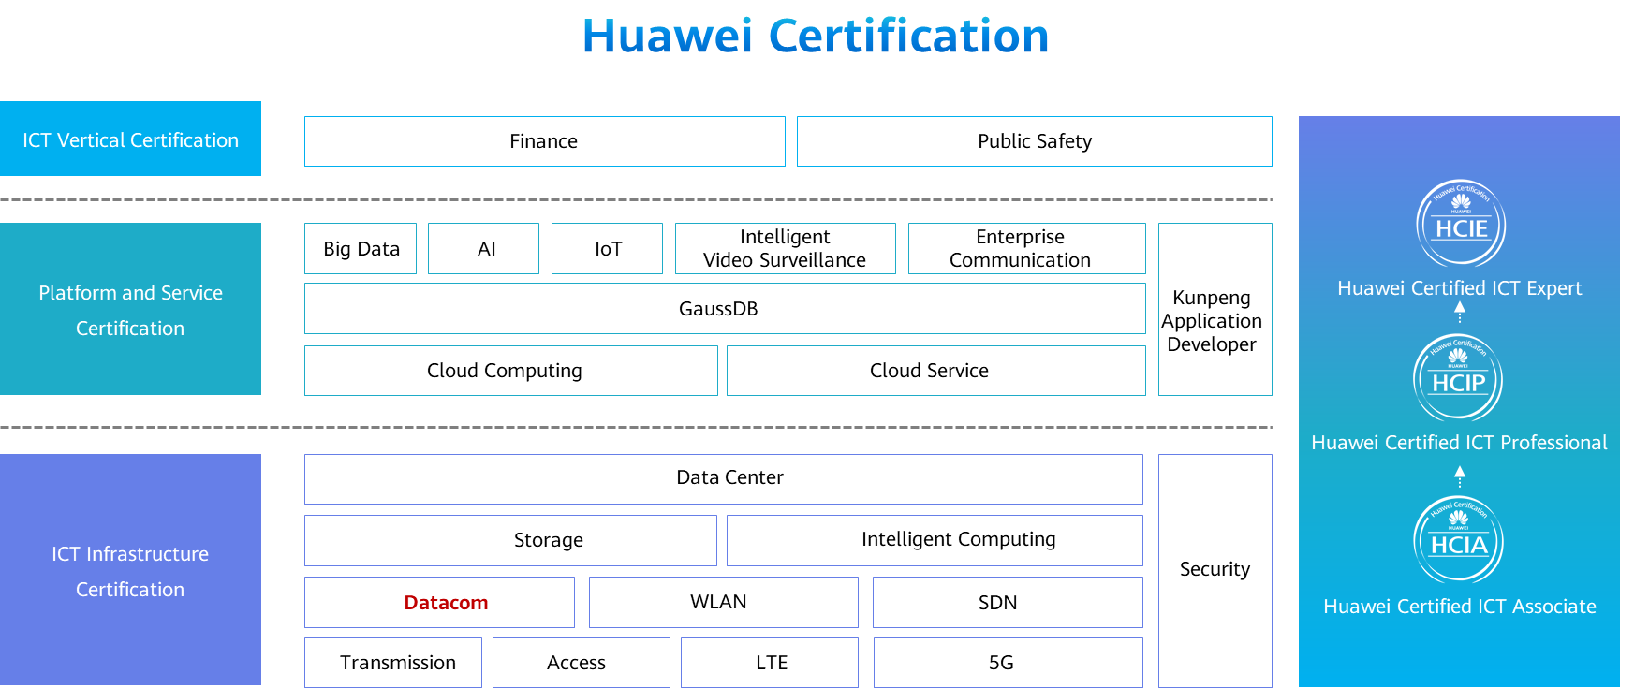

Contents

[1 OSPF Basics 1](#_Toc60148983)

[1.1 Foreword 1](#_Toc60148984)

[1.2 Objectives 1](#_Toc60148985)

[1.3 OSPF Overview 1](#_Toc60148986)

[1.3.1 Why Are Dynamic Routing Protocol Used? 1](#_Toc60148987)

[1.3.2 Classification of Dynamic Routing Protocols 2](#_Toc60148988)

[1.3.3 Distance-Vector Routing Protocol 2](#_Toc60148989)

[1.3.4 Link-State Routing Protocol 3](#_Toc60148990)

[1.3.5 Summary of Link-State Routing Protocols 5](#_Toc60148991)

[1.3.6 Introduction to OSPF 5](#_Toc60148992)

[1.3.7 Basic OSPF Concepts 6](#_Toc60148993)

[1.3.8 OSPF Packet Types 8](#_Toc60148994)

[1.3.9 Three Types of OSPF Entries 8](#_Toc60148995)

[1.4 OSPF Working Mechanism 10](#_Toc60148996)

[1.4.1 Relationships Between OSPF Routers 10](#_Toc60148997)

[1.4.2 Process of Establishing an OSPF Adjacency Relationship 10](#_Toc60148998)

[1.4.3 Review of the OSPF Neighbor Table 13](#_Toc60148999)

[1.4.4 OSPF Network Types 13](#_Toc60149000)

[1.4.5 Background of DR and BDR 15](#_Toc60149001)

[1.4.6 DR and BDR 15](#_Toc60149002)

[1.4.7 OSPF Domain and Single Area 16](#_Toc60149003)

[1.4.8 Multi-Area OSPF 16](#_Toc60149004)

[1.4.9 Types of OSPF Routers 17](#_Toc60149005)

[1.4.10 Typical OSPF Single-Area and Multi-Area Networking 18](#_Toc60149006)

[1.5 Typical OSPF Configuration 19](#_Toc60149007)

[1.5.1 Basic OSPF Configuration Commands 19](#_Toc60149008)

[1.5.2 OSPF Configuration Example 20](#_Toc60149009)

[1.6 Quiz 23](#_Toc60149010)

[1.7 Summary 24](#_Toc60149011)

# OSPF Basics

## Foreword

Static routes are manually configured. If a network topology changes, static routes have to be manually adjusted, which restricts the large-scale application of static routes on the live network.

Dynamic routing protocols are widely used on live networks because of their high flexibility, high reliability, and easy scalability. The Open Shortest Path First (OSPF) protocol is a widely used dynamic routing protocol.

This course describes basic concepts, working mechanism, and basic configurations of OSPF.

## Objectives

On completion of this course, you will be able to:

* Describe the advantages and classification of dynamic routing protocols.
* Describe basic OSPF concepts and usage scenarios.
* Describe the working mechanism of OSPF.
* Implement basic OSPF configurations.

## OSPF Overview

### Why Are Dynamic Routing Protocol Used?

Static routes are manually configured and maintained, and the command lines are simple and clear. They apply to small-scale or stable networks. Static routes have the following disadvantages:

* Unable to adapt to large-scale networks: As the number of devices increases, the configuration workload increases sharply.
* Unable to dynamically respond to network changes: If the network topology changes, the network cannot automatically converge, and static routes must be manually modified.

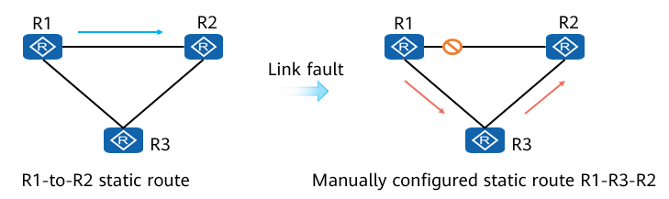

### Classification of Dynamic Routing Protocols

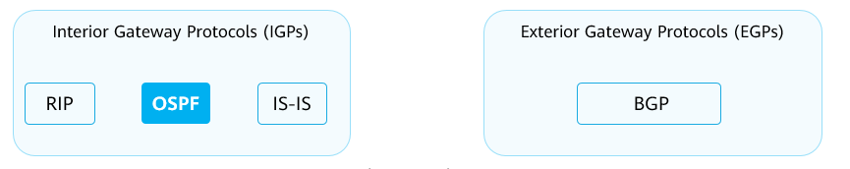

By Ass

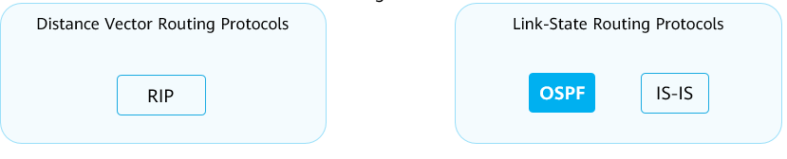

By working mechanisms and algorithms

BGP uses the path-vector algorithm, which is a modified version of the distance-vector algorithm.

### Distance-Vector Routing Protocol

A router running a distance-vector routing protocol periodically floods routes. Through route exchange, each router learns routes from neighboring routers and installs the routes into its routing table.

Each router on a network is clear only about where the destination is and how far the destination is, but unclear about the whole network topology. This is the essence of the distance-vector algorithm.

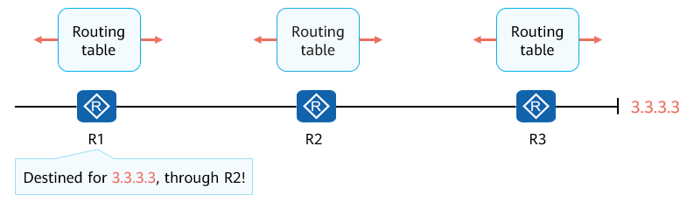

Distance-Vector Routing Protocol

### Link-State Routing Protocol

LSA Flooding

* Different from a distance-vector routing protocol, a link-state routing protocol advertises link status information rather than routes in the routing table. Routers that run a link-state routing protocol establish a neighbor relationship and then exchange Link State Advertisements (LSAs).

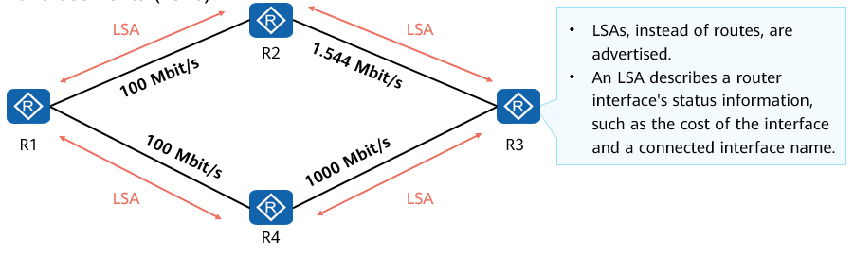

Link-State Routing Protocol - LSA Flooding

* Each router generates an LSA that describes status information about its directly connected interface. The LSA contains the interface cost and the relationship between the router and its neighboring routers.

LSDB Creation

* Each router generates LSAs and adds the received LSAs to its own link state database (LSDB). Routers learn the whole network topology through the LSDB.

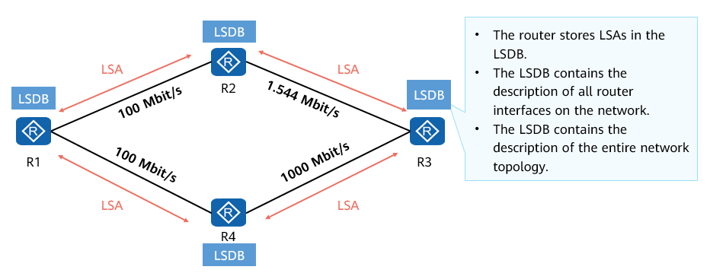

Link-State Routing Protocol - LSDB Creation

SPF Calculation

* Each router uses the Shortest Path First (SPF) algorithm and LSDB information to calculate routes. Each router calculates a loop-free tree with itself as the root and the shortest path. With this tree, a router determines the optimal path to each corner of a network.

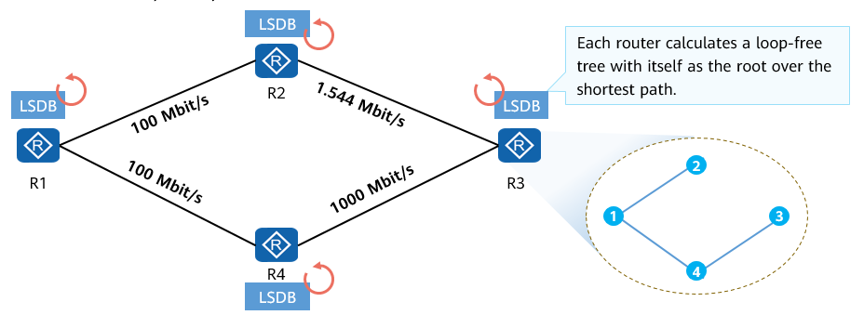

Link-State Routing Protocol - SPF Calculation

* SPF is a core algorithm of OSPF and used to select preferred routes on a complex network.

Routing Table Generation

* Ultimately, the router installs routes for the calculated preferred paths into its routing table.

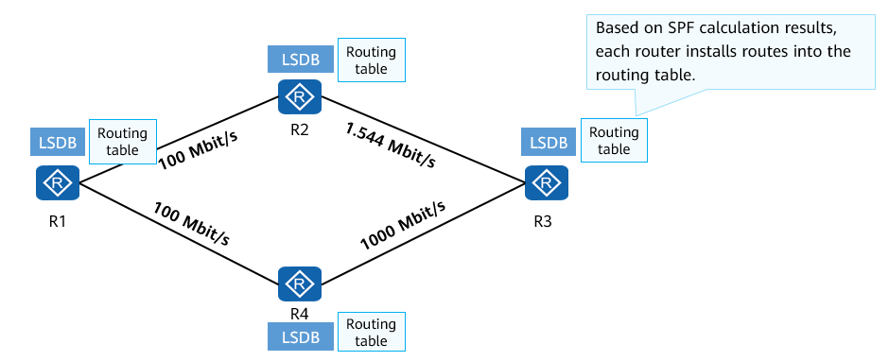

Link-State Routing Protocol - Routing Table Generation

### Summary of Link-State Routing Protocols

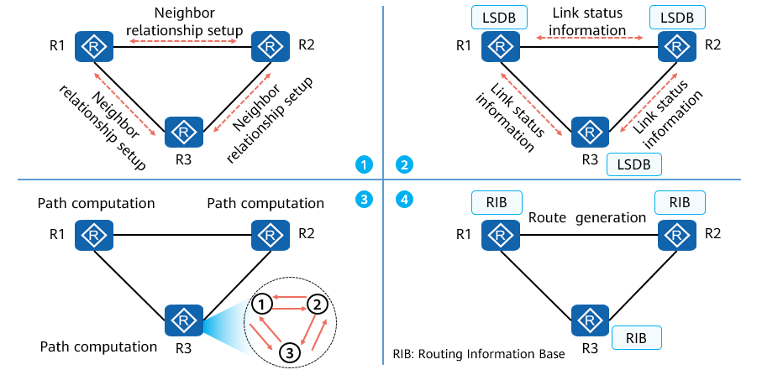

Summary of Link-State Routing Protocols

The implementation of a link-state routing protocol is as follows:

* Step 1: Establishes a neighbor relationship between neighboring routers.
* Step 2: Exchanges link status information and synchronizes LSDB information between neighbors.
* Step 3: Calculates an optimal path.
* Step 4: Generates route entries based on the shortest path tree and loads the routing entries to the routing table.

### Introduction to OSPF

OSPF is a typical link-state routing protocol and one of the widely used IGPs in the industry.

OSPFv2, as defined in RFC 2328, is designed for IPv4. OSPFv3, as defined in RFC 2740, is designed for IPv6. Unless otherwise specified, OSPF in this presentation refers to OSPFv2.

OSPF routers exchange link status information, but not routes. Link status information is key information for OSPF to perform topology and route calculation.

An OSPF router collects link status information on a network and stores the information in the LSDB. Routers are aware of the intra-area network topology and be able to calculate loop-free paths.

Each OSPF router uses the SPF algorithm to calculate the shortest path to a specific destination. Routers generate routes based on these paths and install the routes to the routing table.

OSPF supports the variable length subnet mask (VLSM) mechanism and manual route summarization.

The multi-area design enables OSPF to support a larger network.

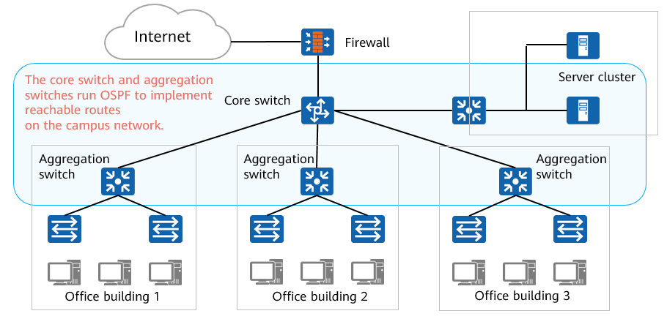

OSPF Application on a Campus Network

### Basic OSPF Concepts

Area

* The OSPF area keyword identifies an OSPF area.
* The area is considered as a logical group, and each group is identified by an area ID.

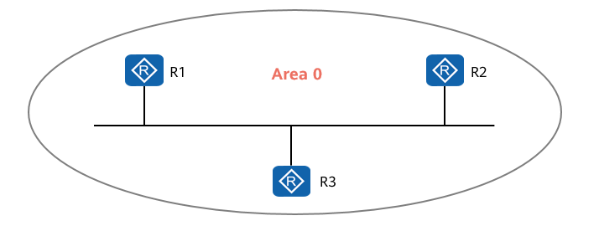

Area

Router ID

* A router ID uniquely identifies a router in an OSPF area.
* The router ID can be manually specified or automatically assigned by the system.

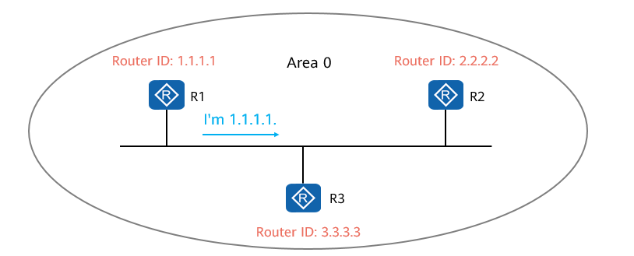

Router ID

* In actual projects, OSPF router IDs are manually set for devices. Ensure that the router IDs of any two devices in an OSPF area are different. Generally, the router ID is set the same as the IP address of an interface (usually a Loopback interface) on the device.

Cost Value

* OSPF uses costs as route metric values. Each OSPF-enabled interface maintains a cost value. Default cost value = , where, 100 Mbit/s is the default reference value specified by OSPF and is configurable.
* Generally, the cost of an OSPF route is the sum of costs of all inbound interfaces along a path from the destination network segment to the local router.

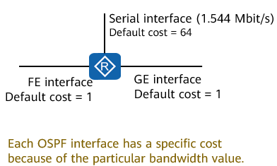

Cost Value of an OSPF Interface

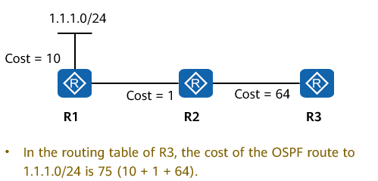

Accumulated Costs on an OSPF Path

### OSPF Packet Types

There are five types of OSPF protocol packets and implement different functions in interaction between OSPF routers.

OSPF Packet Types

|  |  |
| --- | --- |
| Packet Name | Function |
| Hello | Is periodically sent to discover and maintain OSPF neighbor relationships. |
| Database Description | Describes the summary of the local LSDB, which is used to synchronize the LSDBs of two devices. |
| Link State Request | Requests a needed LSA from a neighbor. LSRs are sent only after DD packets have been successfully exchanged. |
| Link State Update | Is sent to advertise a requested LSA to a neighbor. |
| Link State ACK | Is used to acknowledge the receipt of an LSA. |

### Three Types of OSPF Entries

Entries in the Neighbor Table

* OSPF provides entries in three important tables: OSPF neighbor table, LSDB table, and OSPF routing table. For the OSPF neighbor table, you need to know:
  + Before OSPF transmits link status information, OSPF neighbor relationships must be established.
  + OSPF neighbor relationships are established by exchanging Hello packets.
  + The OSPF neighbor table describes the status of the neighbor relationship between OSPF routers. You can run the **display ospf peer** command to view status information.

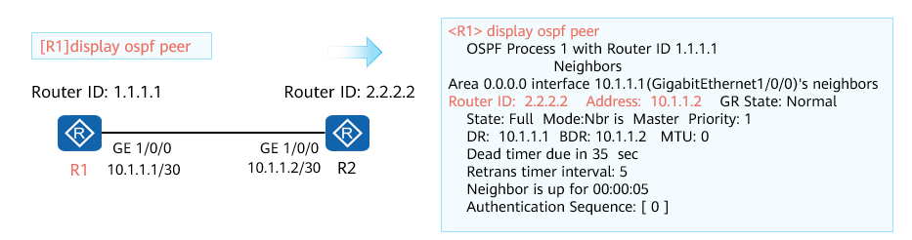

Entries in the Neighbor Table

* The OSPF neighbor table contains much key information, such as router IDs and interface addresses of neighboring devices. For more details, see "OSPF Working Mechanism".

Entries in the LSDB Table

* For the OSPF LSDB table, you need to know:
  + An LSDB stores LSAs generated by a router itself and received from neighbors. In this example, the LSDB of R1 contains three LSAs.
  + The **Type** field indicates an LSA type, and the **AdvRouter** field indicates the router that sends the LSA.
  + Run the **display ospf lsdb** command to query the LSDB.

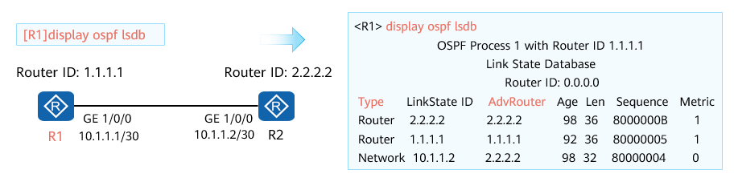

Entries in the LSDB Table

* For more information about LSAs, see information provided in HCIP-Datacom courses.

Entries in the OSPF Routing Table

* For the OSPF routing table, you need to know:
  + The OSPF routing table and the router routing table are different. In this example, the OSPF routing table contains three routes.
  + An OSPF routing table contains information, such as the destination IP address, cost, and next-hop IP address, which guides packet forwarding.
  + Run the **display ospf routing** command to query the OSPF routing table.

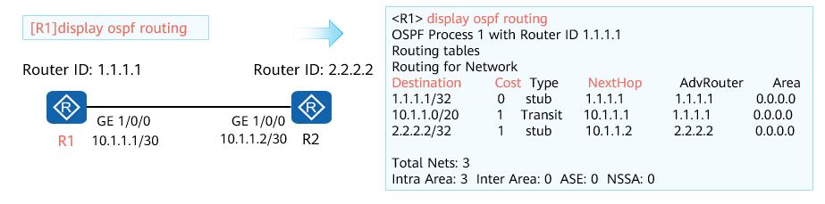

Entries in the OSPF Routing Table

* For more information about the OSPF routing table, see information provided in HCIP-Datacom courses.

## OSPF Working Mechanism

### Relationships Between OSPF Routers

There are two important concepts about the relationship between OSPF routers: neighbor relationship and adjacency.

On a simple network, two routers are directly connected. OSPF is enabled on interconnected interfaces. The routers start to send and listen to Hello packets. After the two routers discover each other through Hello packets, they establish a neighbor relationship.

The establishment of a neighbor relationship is just the beginning. A series of packets, such as DD, LSR, LSU, and LSAck packets, will be exchanged later. When LSDB synchronization between two routers is complete and the two routers start to calculate routes independently, the two routers establish an adjacency.

### Process of Establishing an OSPF Adjacency Relationship

OSPF adjacency relationship establishment involves four steps: establishing a neighbor relationship, negotiating the master/slave status, exchanging LSDB information, and synchronizing LSDBs.

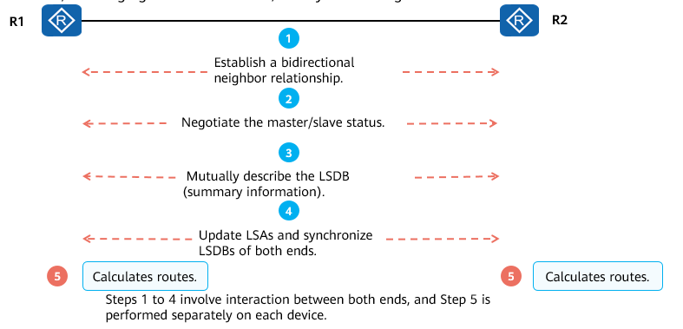

Process of Establishing an OSPF Adjacency Relationship

Step 1:

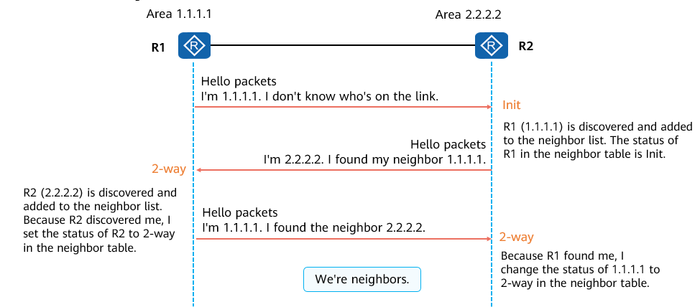

Step 1

* When an OSPF router receives the first Hello packet from another router, the OSPF router changes from the Down state to the Init state.
* When an OSPF router receives a Hello packet in which the neighbor field contains its router ID, the OSPF router changes from the Init state to the 2-way state.

Steps 2 and 3:

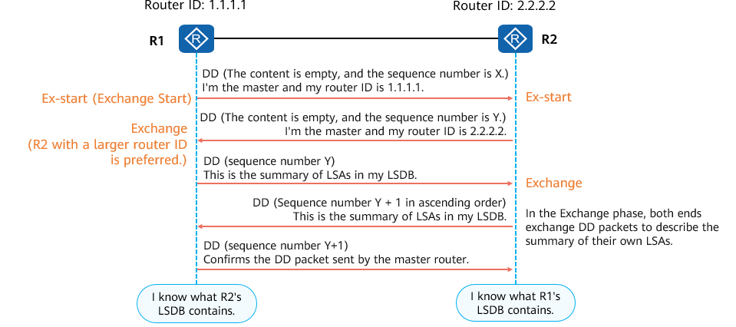

Steps 2 and 3

* After the neighbor state machine changes from 2-way to Exstart, the master/slave election starts.
  + The first DD packet sent from R1 to R2 is empty, and its sequence number is assumed to be X.
  + R2 also sends the first DD packet to R1. In the examples provided in this presentation, the sequence number of the first DD packet is Y.
  + The master/slave relationship is selected based on the router ID. A larger router ID indicates a higher priority. The router ID of R2 is greater than that of R1. Therefore, R2 becomes the master device. After the master/slave role negotiation is complete, R1's status changes from Exstart to Exchange.
* After the neighbor status of R1 changes to Exchange, R1 sends a new DD packet containing its own LSDB description. The sequence number of the DD packet is the same as that of R2. After R2 receives the packet, the neighbor status changes from Exstart to Exchange.
* R2 sends a new DD packet to R1. The DD packet contains the description of its own LSDB and the sequence number of the DD packet is Y + 1.
* As a backup router, R1 needs to acknowledge each DD packet sent by R2. The sequence number of the response packet is the same as that of the DD packet sent by R2.
* After sending the last DD packet, R1 changes the neighbor status to Loading.

Step 4:

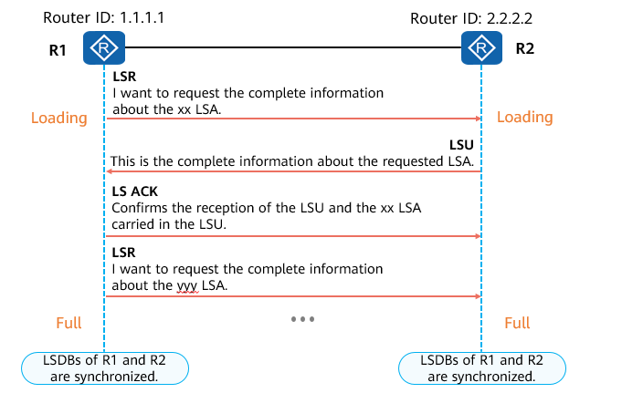

Step 4

* After the neighbor status changes to Loading, R1 sends an LSR to R2 to request the LSAs that are discovered through DD packets in the Exchange state but do not exist in the local LSDB.
* After receiving the LSU, R2 sends an LSU to R1. The LSU contains detailed information about the requested LSAs.
* After R1 receives the LSU, R1 replies with an LSAck to R2.
* During this process, R2 also sends an LSA request to R1. When the LSDBs on both ends are the same, the neighbor status changes to Full, indicating that the adjacency has been established successfully.

### Review of the OSPF Neighbor Table

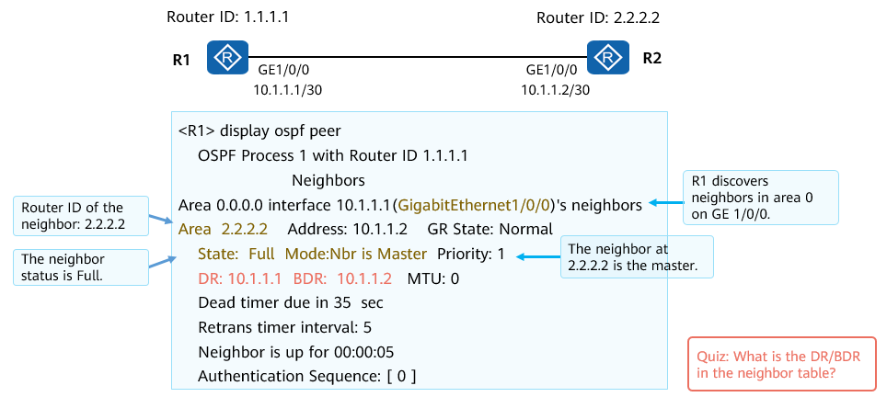

OSPF Neighbor Table

Fields displayed in the **display ospf peer** command output are as follows:

* OSPF Process 1 with Router ID 1.1.1.1: The local OSPF process ID is 1, and the local OSPF router ID is 1.1.1.1.
* Area ID of the neighboring OSPF router.
* Address: address of the neighbor interface.
* GR State: GR status after OSPF GR is enabled. GR is an optimized function. The default value is Normal.
* State: neighbor status. In normal cases, after LSDB synchronization is complete, the neighbor stably stays in the Full state.
* Mode: whether the local device is the master or backup device during link status information exchange.
* Priority: priority of the neighboring router. The priority is used for DR election.
* DR: designated router.
* BDR: backup designated router.
* MTU: MTU of a neighbor interface.
* Retrans timer interval: interval (in seconds) at which LSAs are retransmitted.
* Authentication Sequence: authentication sequence number.

### OSPF Network Types

Before learning concepts of the DR and BDR, understand OSPF network types.

The OSPF network type is a very important interface variable. This variable affects OSPF operations on interfaces. For example, it determines how to send OSPF packets and whether to elect a DR or BDR.

The default OSPF network type of an interface depends on the data link layer encapsulation used by the interface.

As shown in the figure, OSPF has four network types: broadcast, NBMA, P2MP, and P2P.

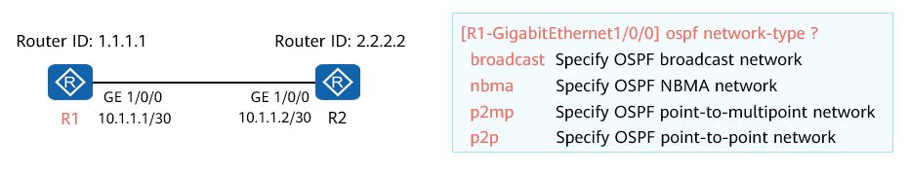

OSPF Network Types

Generally, the network types of OSPF interfaces at both ends of a link must be the same. Otherwise, the two interfaces cannot establish a neighbor relationship.

An OSPF network type can be manually changed on an interface to adapt to different network scenarios. For example, you can change the BMA network type to P2P.

Point-to-Point (P2P)

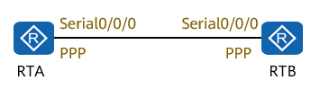

Point-to-Point (P2P)

* P2P indicates that only two network devices can be connected on a link.
* A typical example is a PPP link. When an interface uses PPP encapsulation, the default network type of the OSPF interface is P2P.

Broadcast Multiple Access (BMA)

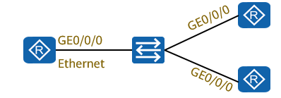

Broadcast Multiple Access (BMA)

* BMA is also called broadcast. It refers to an environment that allows multiple devices to access and supports broadcast.
* A typical example is an Ethernet network. When an interface uses Ethernet encapsulation, the default network type of the OSPF interface is BMA.

Non-Broadcast Multiple Access (NBMA)

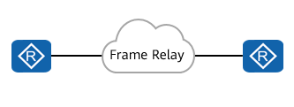

Non-Broadcast Multiple Access (NBMA)

* NBMA refers to an environment that allows multiple network devices to access but does not support broadcast.
* A typical example is a Frame Relay (FR) network.

Point-to-Multipoint (P2MP)

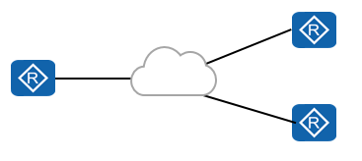

Point-to-Multipoint (P2MP)

* A P2MP network is formed by bundling endpoints of multiple P2P links.
* No link layer protocol is considered as a P2MP network by default. This type must be manually changed from another network type.
* For example, a non-full-mesh NBMA network can be changed to a P2MP network.

### Background of DR and BDR

Multi-access (MA) networks are classified into BMA and NBMA networks. Ethernet is a typical broadcast multi-access network.

On an MA network, if each OSPF router establishes OSPF adjacencies with all the other routers, excessive OSPF adjacencies exist on the network, which increases the load on the devices and the number of OSPF packets flooded on the network.

Once the network topology changes, LSA flooding on the network may waste bandwidth and device resources.

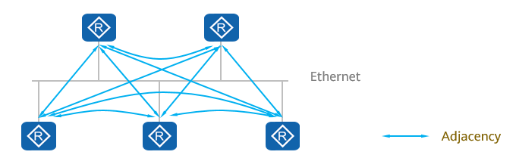

Background of DR and BDR

### DR and BDR

To optimize OSPF neighbor relationships on an MA network, the OSPF protocol specifies three types of OSPF routers: DR, BDR, and DRother.

Only the DR and BDR can establish adjacencies with other OSPF routers. DRothers do not establish OSPF adjacencies with one another, and their relationship is in the 2-way state.

The BDR monitors the status of the DR and takes over the role of the DR if the existing DR fails.

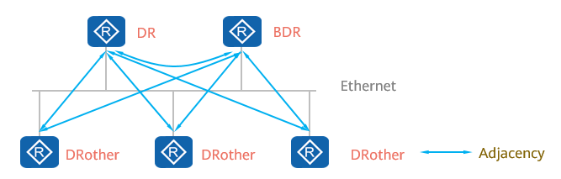

DR and BDR

Election rule: The interface with a higher OSPF DR priority becomes the DR of the MA. If the priorities (default value of 1) are the same, the router (interface) with a higher OSPF router ID is elected as the DR, and the DR is non-preemption.

### OSPF Domain and Single Area

An OSPF domain is a network that consists of a series of contiguous OSPF network devices that use the same policy.

An OSPF router floods LSAs in the same area. To ensure that all routers have the same understanding of the network topology, LSDBs need to be synchronized within an area.

If there is only one OSPF area, the number of OSPF routers increases with the network scale. This causes the following problems:

* The LSDB becomes larger and larger, and the size of the OSPF routing table increases. A large number of router resources are consumed, device performance deteriorates, and data forwarding is affected.
* It is difficult to calculate routes based on a large LSDB.
* When the network topology changes, LSA flooding and SPF recalculation on the entire network bring heavy loads.

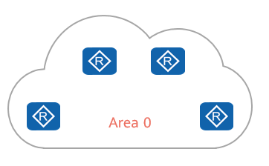

OSPF Domain and Single Area

### Multi-Area OSPF

OSPF introduces the concept of area. An OSPF domain is divided into multiple areas to support larger-scale networking.

The OSPF multi-area design reduces the flooding scope of LSAs and effectively controls the impact of topology changes within an area, optimizing the network.

Routes can be summarized at the area border to reduce the size of the routing table.

Multi-area improves network scalability and facilitates large-scale network construction.

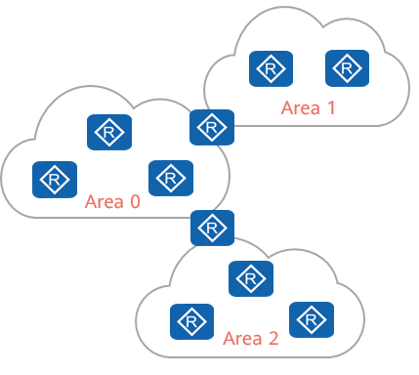

Multi-Area OSPF

Types of areas: Areas can be classified into backbone areas and non-backbone areas. Area 0 is a backbone area. All areas except area 0 are called non-backbone areas.

Multi-area interconnection: To prevent inter-area loops, non-backbone areas cannot be directly connected to each other. All non-backbone areas must be connected to a backbone area.

### Types of OSPF Routers

OSPF routers are classified into the following types based on their locations or functions:

* Internal router
* Area border router (ABR)
* Backbone router
* AS boundary router (ASBR)

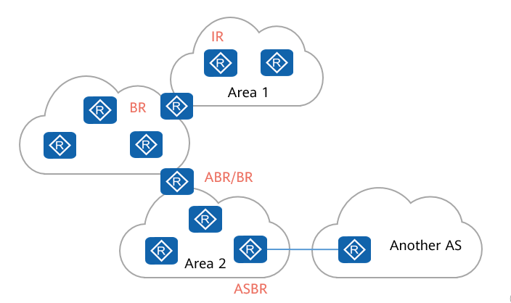

Types of OSPF Routers

Internal router: All interfaces of an internal router belong to the same OSPF area.

ABR: An interface of an ABR belongs to two or more areas, but at least one interface belongs to the backbone area.

Backbone router: At least one interface of a backbone router belongs to the backbone area.

ASBR: exchanges routing information with other ASs. If an OSPF router imports external routes, the router is an ASBR.

### Typical OSPF Single-Area and Multi-Area Networking

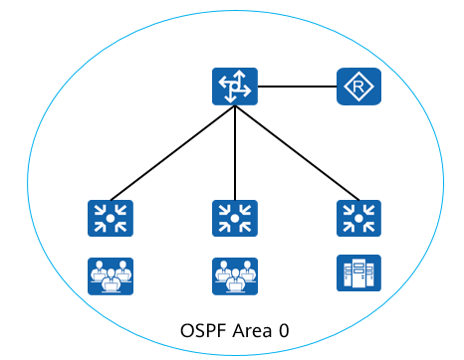

Small- and medium-sized enterprise network (single area)

Small- and medium-sized enterprise networks have a small scale and a limited number of routing devices. All devices can be deployed in the same OSPF area.

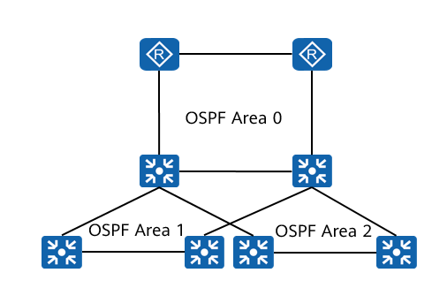

Large enterprise network (multiple areas)

A large-scale enterprise network has a large number of routing devices and is hierarchical. Therefore, OSPF multi-area deployment is recommended.

## Typical OSPF Configuration

### Basic OSPF Configuration Commands

A router ID is selected in the following order: The largest IP address among Loopback addresses is preferentially selected as a router ID. If no Loopback interface is configured, the largest IP address among interface addresses is selected as a router ID.

(System view) Create and run an OSPF process.

[Huawei] **ospf** [ *process-id* | **router-id** *router-id* ]

The *process-id* parameter specifies an OSPF process. The default process ID is 1. OSPF supports multiple processes. Multiple OSPF processes can separately run on the same device. The **router-id** command is used to manually specify the ID of a device. If no ID is specified, the system automatically selects the IP address of an interface as the device ID.

(OSPF view) Create an OSPF area and enter the OSPF area view.

[Huawei] **area** *area-id*

The **area** command creates an OSPF area and displays the OSPF area view.

The *area-id* value can be a decimal integer or in dotted decimal notation. If the value is an integer, it ranges from 0 to 4294967295.

(OSPF area view) Specify the interface that runs OSPF.

[Huawei-ospf-1-area-0.0.0.0] **network** *network-address* *wildcard-mask*

The **network** command specifies the interface that runs OSPF and the area to which the interface belongs. The *network-address* parameter specifies the network segment address of the interface. The *wildcard-mask* parameter is the wildcard of an IP address, which is equivalent to the reverse mask of the IP address (0 is converted to 1, and 1 to 0). For example, 0.0.0.255 indicates that the mask length is 24 bits.

(Interface view) Set an OSPF interface cost.

[Huawei-GE1/0/1] **ospf cost** *cost*

The **ospf cost** command sets a cost for an OSPF interface. By default, OSPF automatically calculates the cost of an interface based on the interface bandwidth. The cost value is an integer ranging from 1 to 65535.

(OSPF view) Set an OSPF bandwidth reference value.

[Huawei-ospf-1] **bandwidth-reference** *value*

The **bandwidth-reference** command sets a bandwidth reference value that is used to calculate interface costs. The value ranges from 1 to 2147483648, in Mbit/s. The default value is 100 Mbit/s.

(Interface view) Set the priority of an interface for DR election.

[Huawei-GigabitEthernet0/0/0] **ospf dr-priority** *priority*

The **ospf dr-priority** command sets a priority for an interface that participates in DR election. A larger value indicates a higher priority. The value ranges from 0 to 255.

### OSPF Configuration Example

Description:

* There are three routers, R1, R2, and R3. R1 and R3 are connected to networks 1.1.1.1/32 and 3.3.3.3/32 (simulated by Loopback 0), respectively. OSPF needs to be used to implement interworking between the two networks. Detailed topology was as follows:

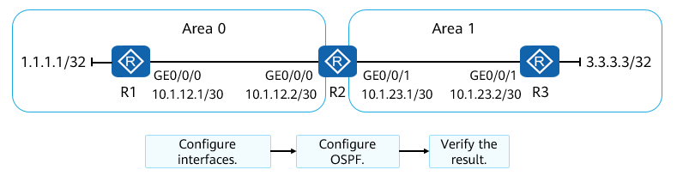

Topology

The configuration process consists of three steps: configuring device interfaces, configuring OSPF, and verifying the result.

Configuring Interfaces

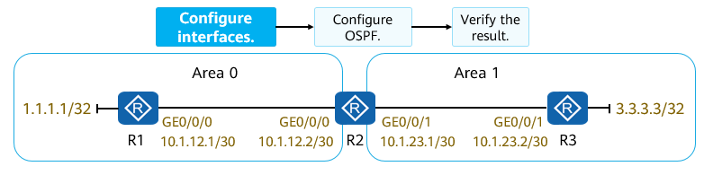

Configuring Interfaces

* Set IP addresses for R1's, R2's, and R3's interfaces according to the plan.

# Configure interfaces of R1.

[R1] interface LoopBack 0

[R1-LoopBack0] ip address 1.1.1.1 32

[R1-LoopBack0] interface GigabitEthernet 0/0/0

[R1-GigabitEthernet0/0/0] ip address 10.1.12.1 30

# Configure interfaces of R2.

[R2] interface GigabitEthernet 0/0/0  
[R2-GigabitEthernet0/0/0] ip address 10.1.12.2 30  
[R2-GigabitEthernet0/0/0] interface GigabitEthernet 0/0/1  
[R2-GigabitEthernet0/0/1] ip address 10.1.23.1 30

# Configure interfaces of R3.

[R3] interface LoopBack 0

[R3-LoopBack0] ip address 3.3.3.3 32

[R3-LoopBack0] interface GigabitEthernet 0/0/1

[R3-GigabitEthernet0/0/1] ip address 10.1.23.2 30

Configuring OSPF

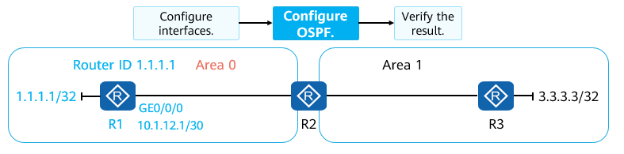

Configuring OSPF (1)

* Planned OSPF parameters: The OSPF process ID is 1. Router IDs of R1, R2, and R3 are 1.1.1.1, 2.2.2.2, and 3.3.3.3 respectively.
* Procedure:
  + Create and run an OSPF process.
  + Create an OSPF area and enter the   
    OSPF area view.
  + Specify the interface that runs OSPF..

# Configure OSPF on R1.

[R1] ospf 1 router-id 1.1.1.1

An inverse mask is specified here.

[R1-ospf-1] area 0

[R1-ospf-1-area-0.0.0.0] network 1.1.1.1 0.0.0.0

[R1-ospf-1-area-0.0.0.0] network 10.1.12.0 0.0.0.3

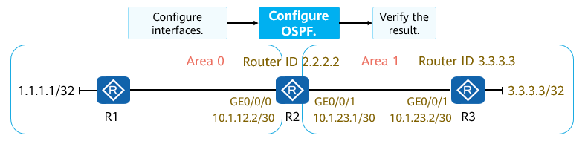

Configuring OSPF (2)

* When configuring OSPF multi-area, be sure to advertise the route destined for a network segment that responds to a specified area.

# Configure OSPF on R2.

[R2] ospf 1 router-id 2.2.2.2

[R2-ospf-1] area 0

[R2-ospf-1-area-0.0.0.0] network 10.1.12.0 0.0.0.3

[R2-ospf-1-area-0.0.0.0] area 1

[R2-ospf-1-area-0.0.0.1] network 10.1.23.0 0.0.0.3

# Configure OSPF on R3.

[R3] ospf 1 router-id 3.3.3.3

[R3-ospf-1] area 1

[R3-ospf-1-area-0.0.0.1] network 3.3.3.3 0.0.0.0

[R3-ospf-1-area-0.0.0.1] network 10.1.23.0 0.0.0.3

Verification

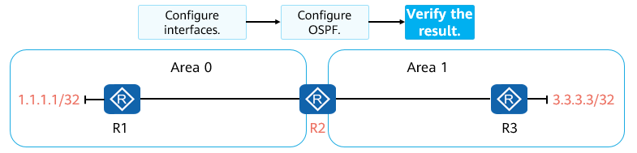

Verification (1)

* Check the OSPF neighbor table on R2.

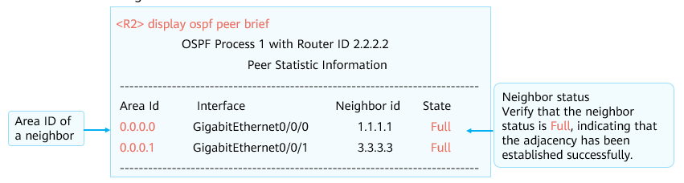

Verification (2)

* Check the routing table on R1 and ping 3.3.3.3 from 1.1.1.1.

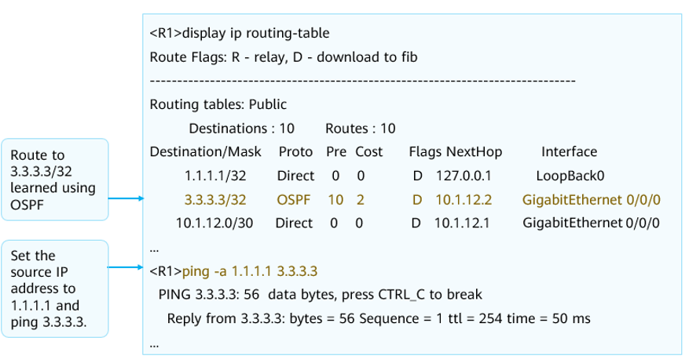

Verification (3)

## Quiz

1. (Single) Which of the following statements about OSPF is incorrect? ( )
2. OSPF Hello packets are sent every 10s by default.
3. In OSPF, non-backbone areas must be connected to backbone areas.
4. The highest adjacency status is 2-way.
5. During DR/BDR election, priority 0 indicates that the DR/BDR is not elected.
6. (Multiple) Two routers run OSPF, but the neighbor relationship cannot be established. Which of the following are possible causes? ( )
7. The router IDs are the same.
8. Interface IP addresses are not in the same network segment.
9. Different regions
10. OSPF processes at both ends are not in the same process.
11. (Multiple) Which of the following network types require DR and BDR for OSPF? ( )
12. BMA
13. P2P
14. NBMA
15. NBMA
16. (Multiple) In the process of establishing OSPF neighbor relationships and adjacencies, which of the following states are stable? ( )
17. Exstart
18. Two-way
19. Exchange
20. Full
21. (Multiple) In which of the following situation will the establishment of adjacencies between routers be triggered? ( )
22. Two routers on a point-to-point link
23. DR and BDR on a broadcast network
24. DRother and DRother on an NBMA network
25. BDR and DRother on a broadcast network
26. (True or False)Each device running OSPF needs to generate LSAs.（ ）
27. True
28. False
29. (True or False)An interface on an ABR must belong to the backbone area.（ ）
30. True
31. False

## Summary

OSPF is a widely used routing protocol on the live network. This presentation describes basic concepts, application scenarios, and basic configurations of OSPF.

The router ID, area, OSPF neighbor table, LSDB table, and OSPF routing table are basic OSPF concepts. Describe the establishment of OSPF neighbor relationships and adjacencies, which helps you better understand the link-state routing protocol.

OSPF has more interesting details, such as LSA types, the SPF calculation process, and the OSPF special area. For more OSPF information, please continue your Huawei HCIP-Datacom certification courses.